**NAAN MUDHALVAN**

SALESFORCE PROJECT REPORT

**SCHOOL MANAGEMENT SYSTEM**

COLLEGE : **PSN INSTITUTE OF TECHNOLOGY AND SCIENCE**

**TEAM ID** : NM2023TMID03335

|  |  |  |
| --- | --- | --- |
| **NAME** | **NM ID** | **REG NO** |
| DEEPAN D | 06ED6A12EC9269FAF8E4F92C7003FE64 | 952420104003 |
| JASMINE J | 07385B225EE2CFAA674401B41B7E5A08 | 952420104010 |
| KALEESWARAN V | 188870D71E130D9B4DC4199E6163494C | 952420104012 |
| MALLIKA DEVI M | F2077AFC7BDACDC82A243314A17BEBA5 | 952420104015 |

**Project Specifications**

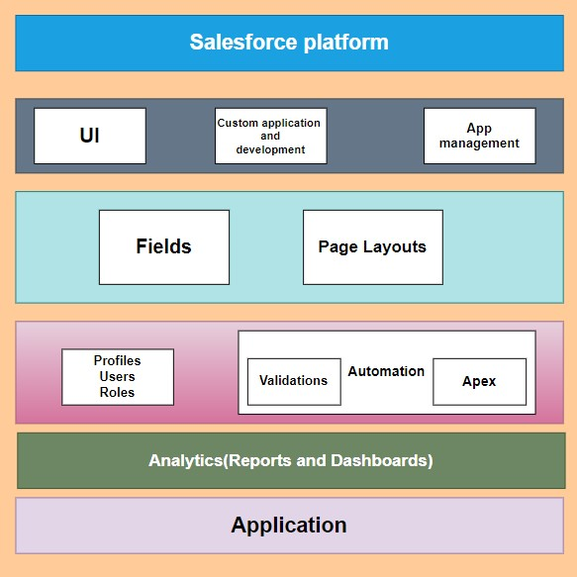The project aim is to provide real-time knowledge for all the students who have basic knowledge of Salesforce and Looking for a real-time project. This project will also help those professionals who are in cross-technology and want to switch to Salesforce. With the help of this project they will gain knowledge and can include it into their resume as well.

**Project Flow:**

In this project you can do hands on practice the configuration as well as customization with

the Data modeling, App building, User Adoption & Apex Code

Milestone 1: Creation of developer account

Milestone 2: Object Creation

Milestone 3 : Tabs Creation

Milestone 4 : Create App

Milestone 5 : Fields & Relationships

Milestone 6 : Profile

Milestone 7 : Role and role hierarchy

Milestone 8 : Users

Milestone 9 : User Adoption

Milestone 10 : Reports

Milestone 11 : Dashboards

Milestone 12 : Flows

Milestone 13 : Apex Classes and Triggers

­

**Preparation Data Modelling**

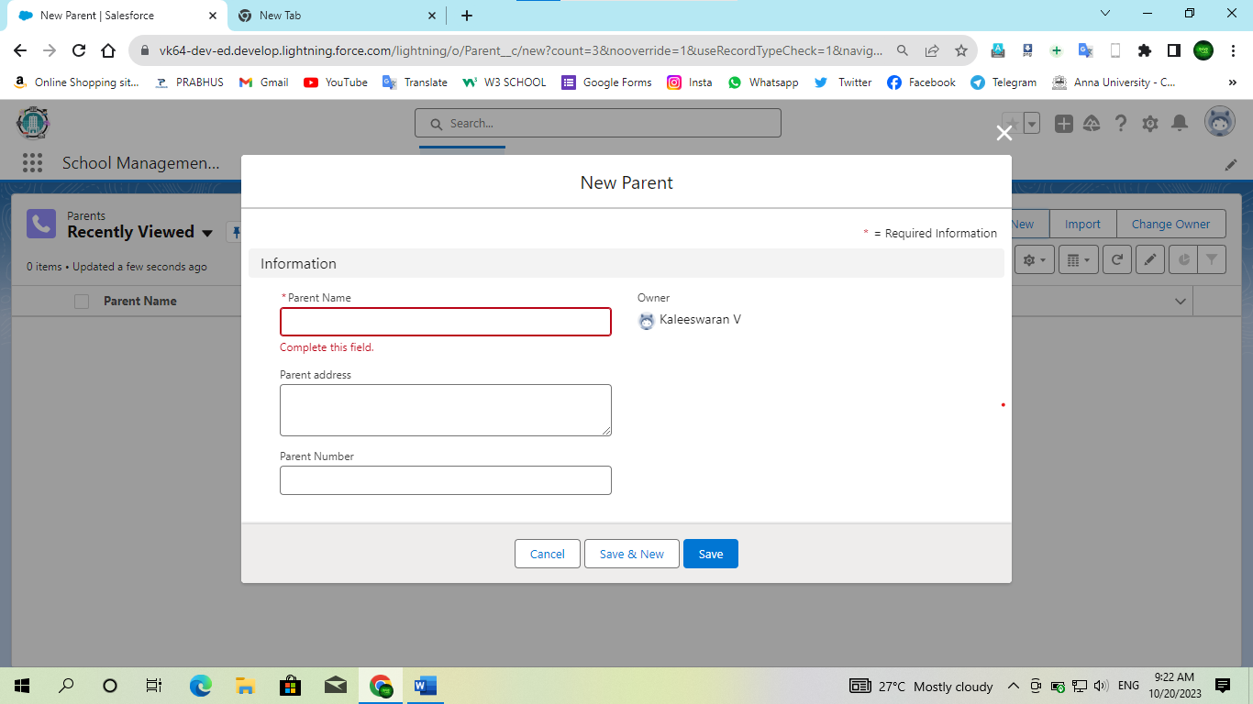**Objects & Fields:-**

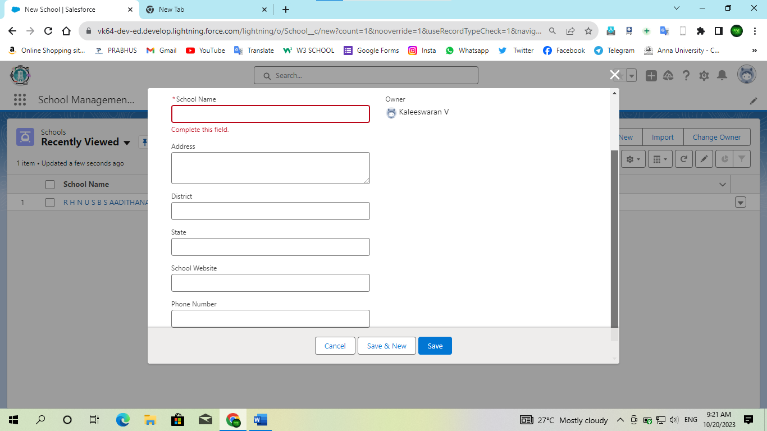

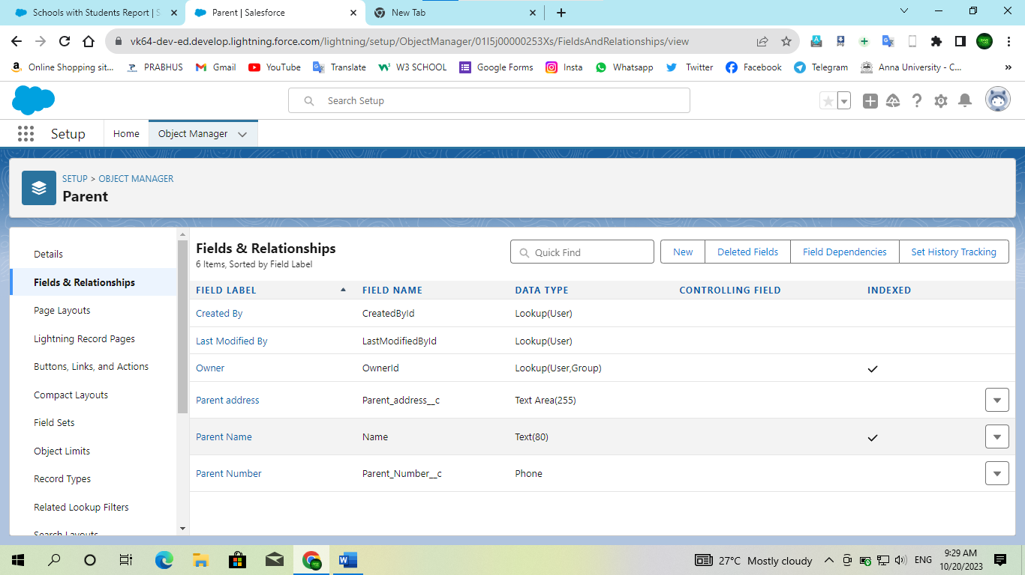

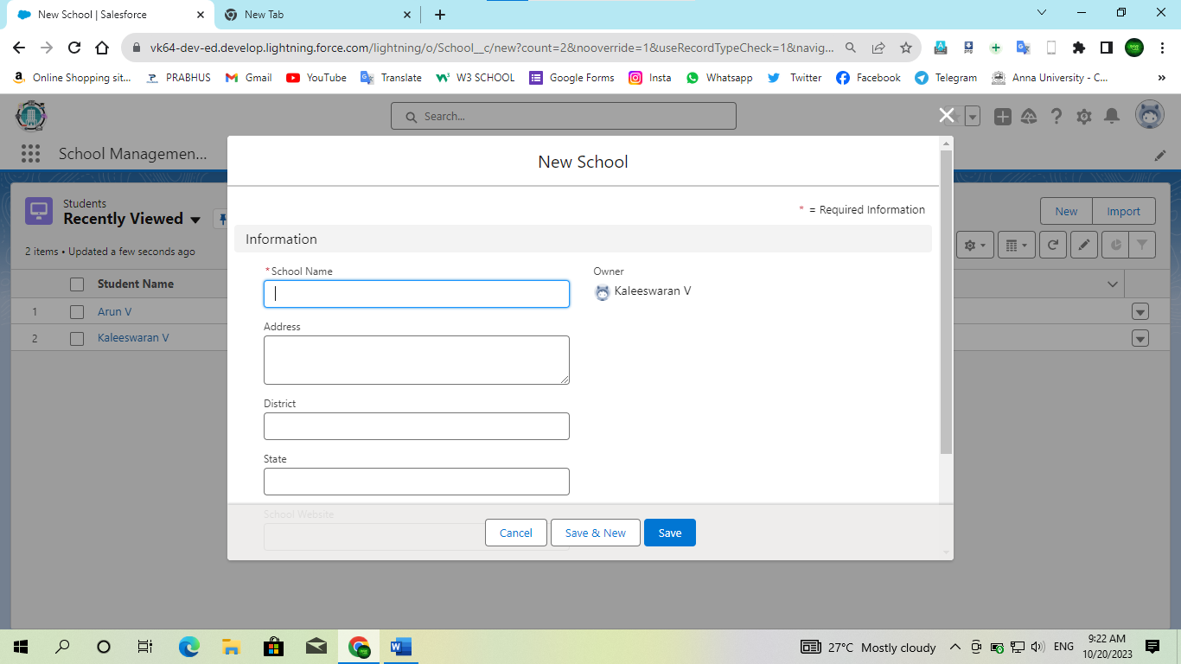

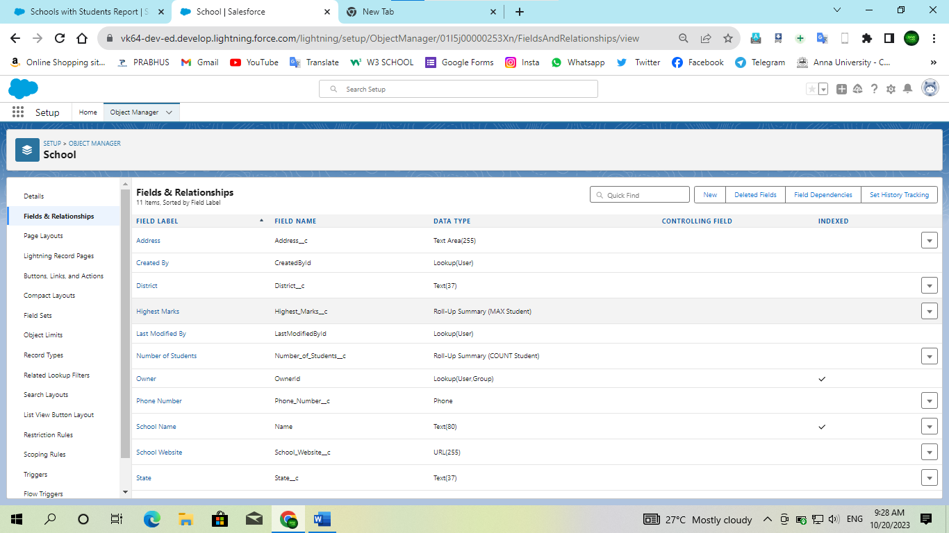

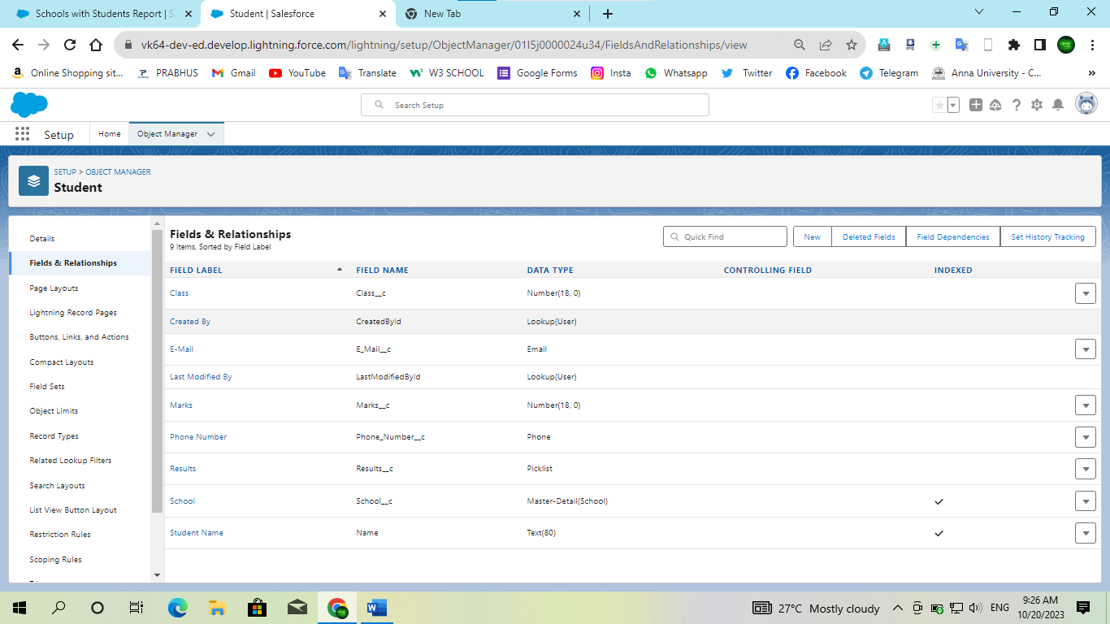

**Users & Data Security**

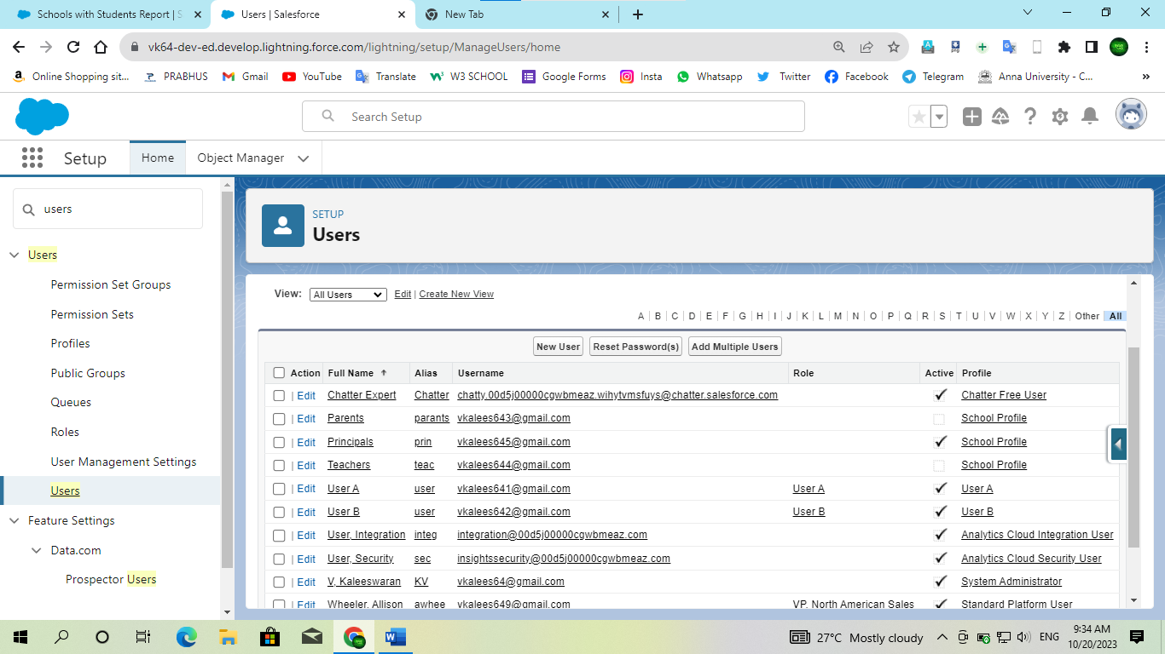



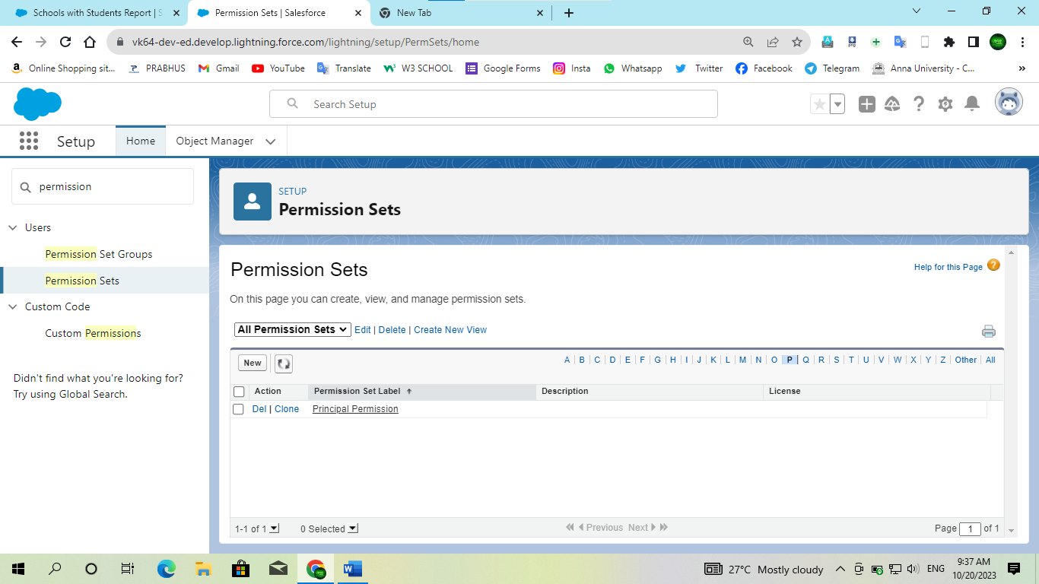

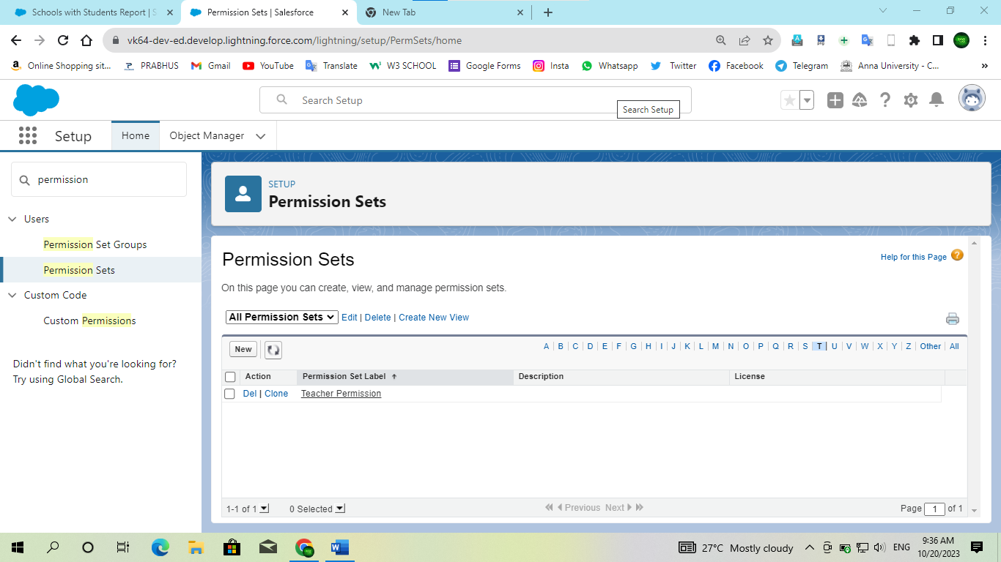

**Automation**

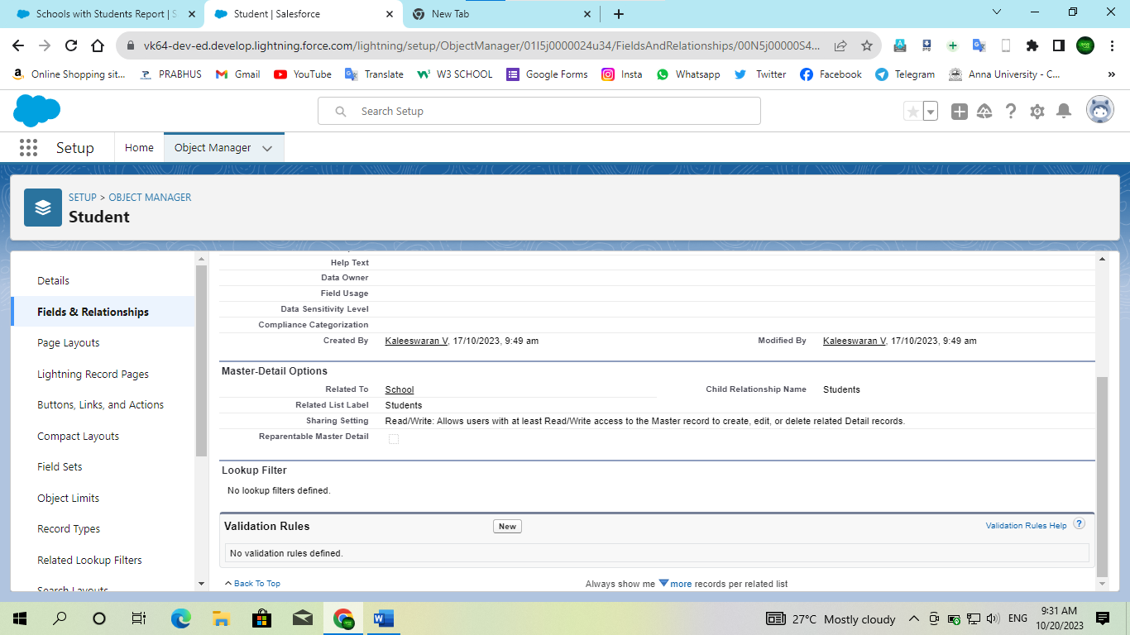

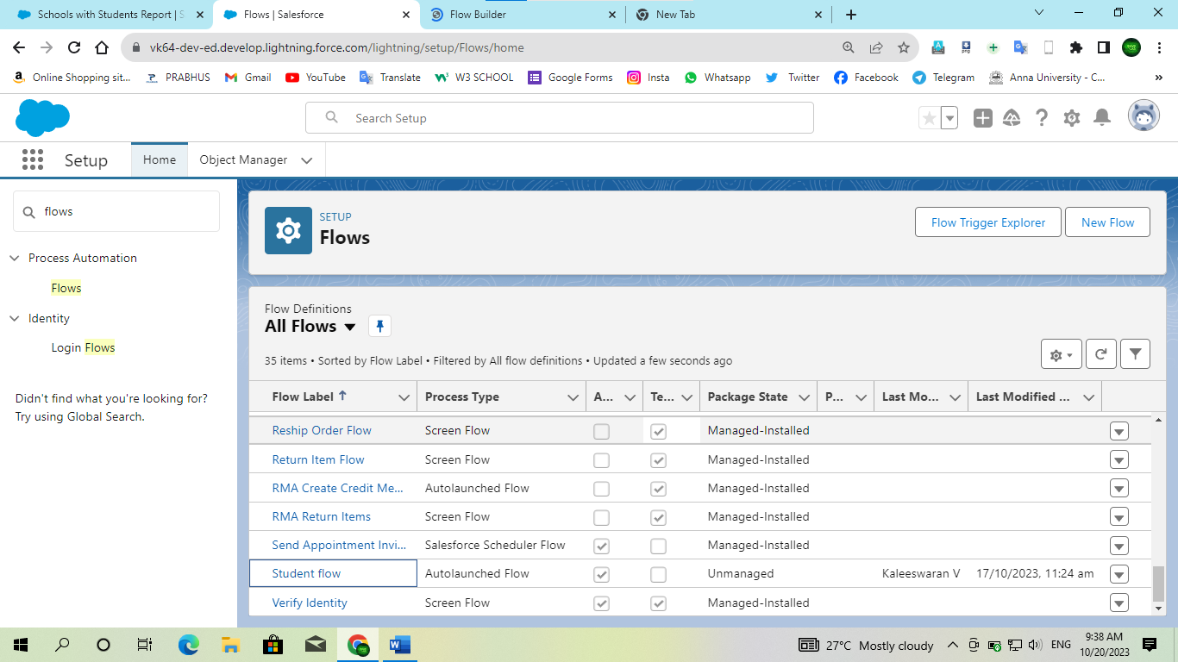

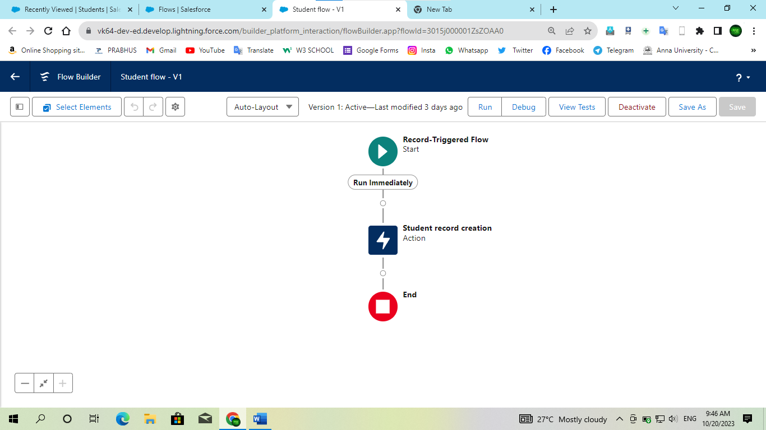

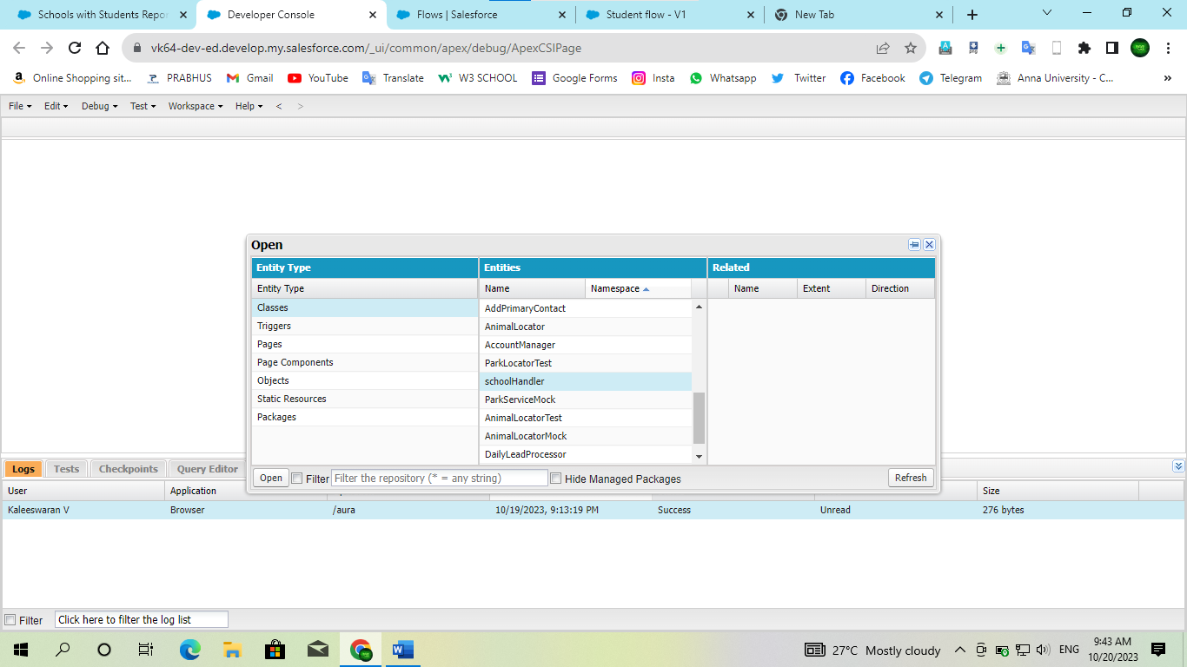

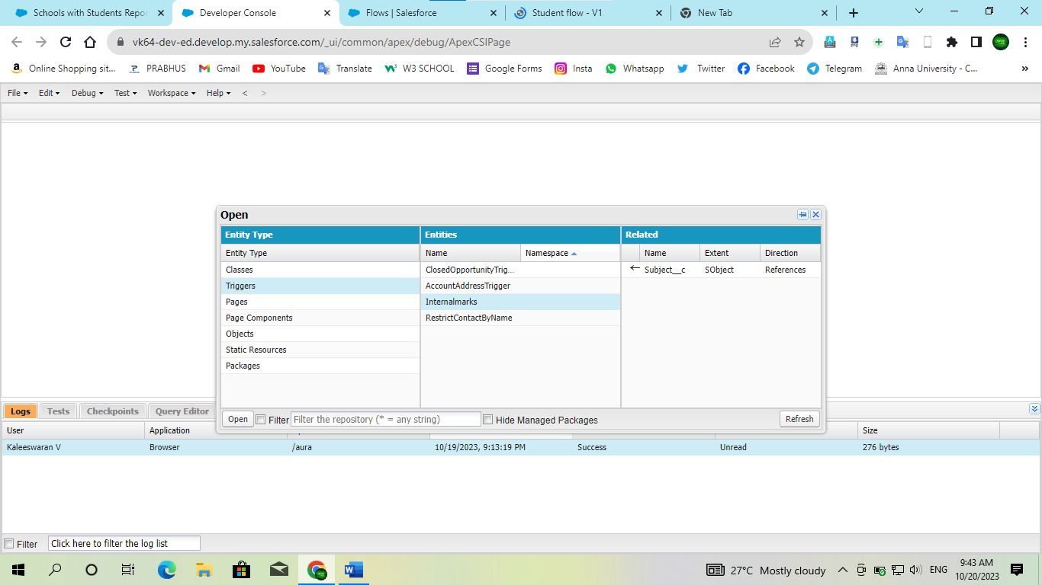

**Reports & Dashboard**

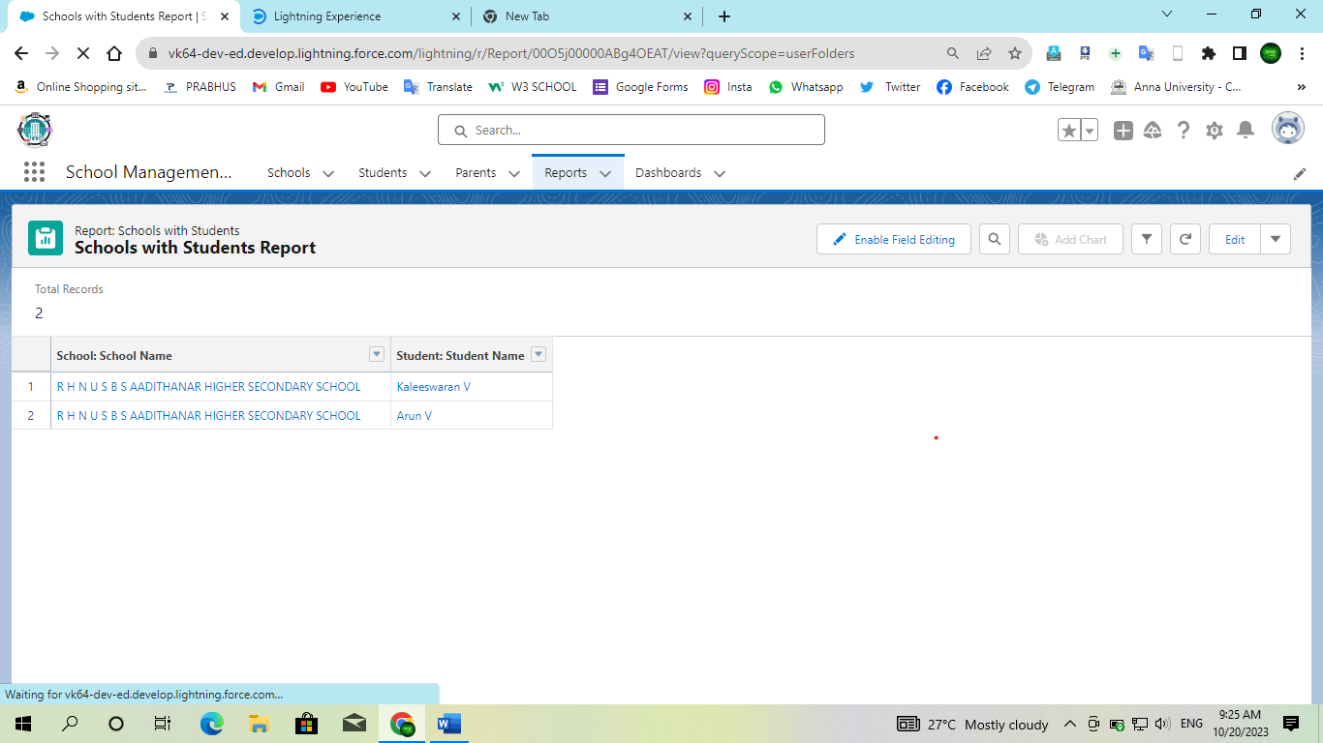

**Project Report/Demonstration**

Video Link : [Click to Access Project Demonstration Video](https://youtu.be/6PMrbECYf2Y)